DML :

Problem
Electricity_ReadingBill(Insert/Update/Delete)

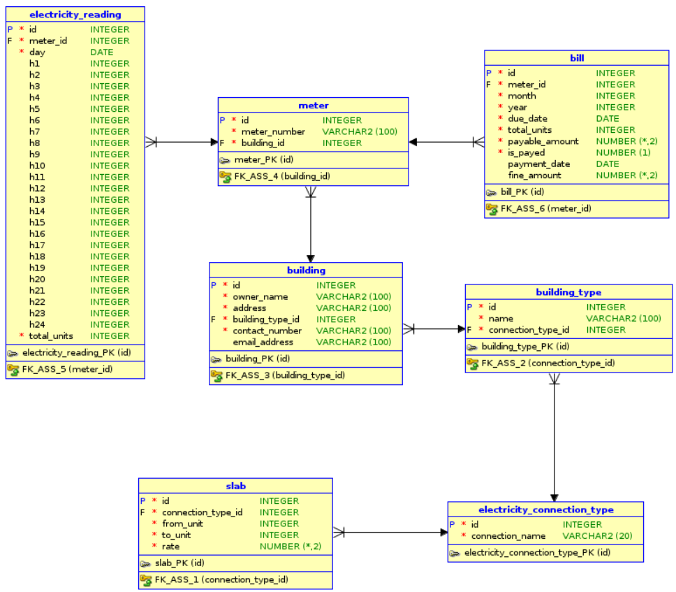

Q 1. Write a query to insert any 3 records into the 'building' table.
Important Note:
1. Before inserting records into the building table, you must insert below two records into the building_type table.
2. Then it is mandatory to refer these building_type_id values to insert the records into the building table.
PLEASE DO NOT REFER TO ANY OTHER IDs IN THE building table.
building id can be your choice
ID | NAME | CONNECTION_TYPE_ID
1 | Shopping Mall | 2
2 | Hotel | 2

Ans:
INSERT INTO building_type VALUES (1, 'Shopping Mall', 2);
INSERT INTO building_type VALUES (2, 'Hotel', 2);
INSERT INTO building VALUES (1, 'Nicholas', 'UK', 1, '123-456-789','nicholas@hotmail.com');
INSERT INTO building VALUES (2, 'Ron Sim', 'US', 2, '123-786-789','ronsm@hotmail.com');
INSERT INTO building VALUES (3, 'Sakshi', 'Kolhapur', 1, '132-761-789','sakss@hotmail.com');

Q 2. Write a query to change the owner_name 'Nicholas' to 'Alexander'.
Ans:
UPDATE building SET owner_name = 'Alexander' WHERE owner_name = 'Nicholas';

Q 3. Write a query to delete the records with owner_name 'Ron Sim' in building table
Ans:
DELETE FROM building WHERE owner_name = 'Ron Sim';

Access:

Problem
Metro_Station(Insert/Update/Drop)

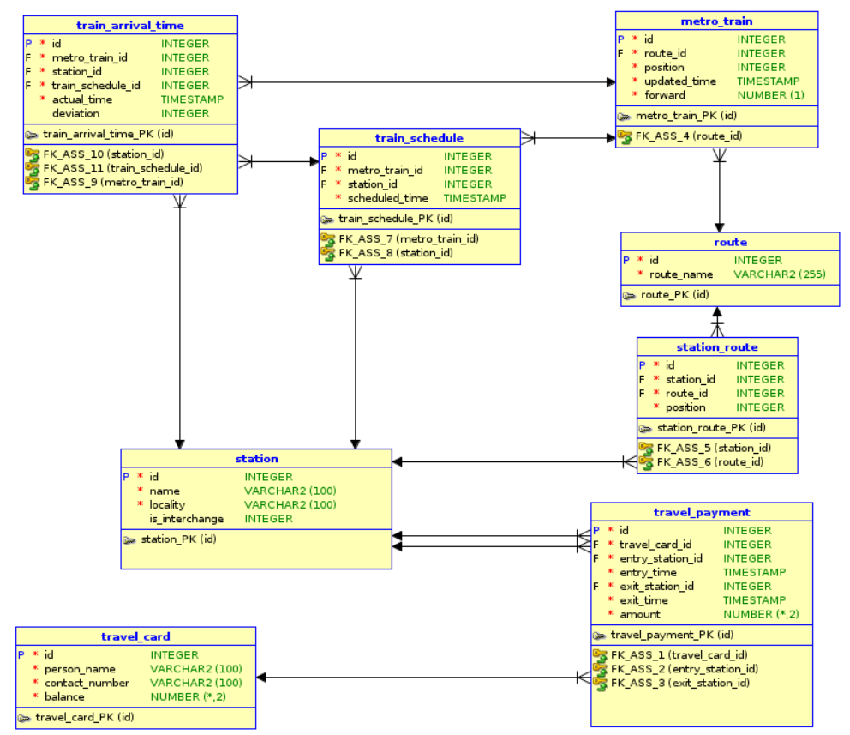

Q 1. Write a query to insert any 4 records into the 'station' table.
Ans:
INSERT INTO station VALUES (1, 'PUNE-West', 'Hinjewadi', 1);
INSERT INTO station VALUES (2, 'PUNE-South', 'Karve Nagar', 0);
INSERT INTO station VALUES (3, 'PUNE-East', 'Hadpsar', 0);
INSERT INTO station VALUES (4, 'PUNE-North', 'Viman Nagar', 1);

Q 2. Write a query to change the route_name from 'East West line' to 'South West line' in the 'route'.
Ans:
UPDATE route SET route_name = 'South West line' WHERE route_name = 'East West line';

Access Additional :

Q 1. Write a query to change the skill name 'CAD' to 'CADCAM'.
Ans:
UPDATE skill SET name = 'CADCAM' WHERE name = 'CAD';

Q 2. Write a query to delete the skill 'Web Design'.
Ans:
DELETE FROM skill WHERE name = 'Web Design';

